CHAPTER 1
INTRODUCTION
1.1 MANUFACTURING PROCESS
The process that involves converting raw materials into a part with specified form and dimension by utilizing resources such as machines and labor is called manufacturing. Moreover, the produced products in large quantities can be sold or taken to the customer for consumption or utilization. The goods or products can be sold to the consumer at a rate higher than the manufacturing cost, and care must be taken to ensure that the fixed cost is affordable to the targeted consumers. Various manufacturing processes are available to transform the raw material into a finished product, as shown in Figure 1.1.
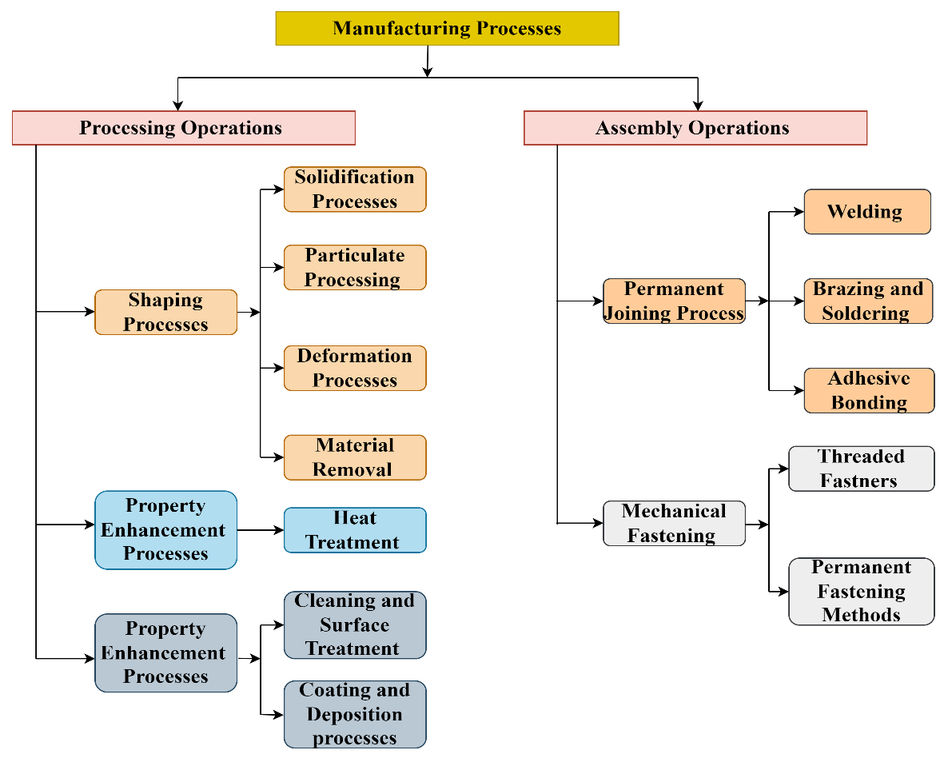

(Source: Mikell Groover 2013)

Figure 1.1 Classification of Manufacturing Processes

    - Machining
Machining is one shaping process that removes material to achieve the intended shape and dimension. It initially originated in 1763 when James Watt designed a boring machine to improve the dimensional accuracy of the cylinder bore. The predominant industrial revolution resulted in the development of the screw-cutting lathe by Henry Maudsley in 1800, which had mechanized tools that facilitated much-précised threading operations to be carried on a job. It is a secondary manufacturing process that effectively removes material to attain a definite form and size from the intended material through physical contact or energy transfer. The machining process is generally classified into two, as shown in Figure 1.2.
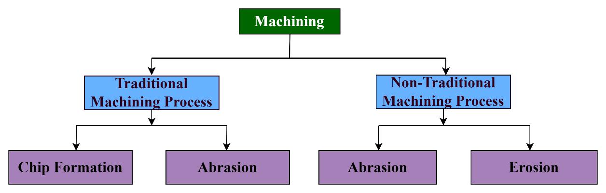
(Source: Boothroyd 2019)
Figure 1.2 Classification of Machining Process
When the material removal is achieved through direct contact between the intended material to be shaped and the tool, the process is called a traditional machining process. During this process, the material is removed in the form of chips. The material is removed from the workpiece with very minimal or no chip formation in this process. Even though the Conventional Machining process has undeniably revolutionized industries to improve productivity, it has some limitations. It is summarized below,
    - Chips are generated while machining.
    - In traditional machining, the workpiece had to be much softer than the tool.
    - Components with intricate and complex profiles are either tricky to machine or impossible.
    - Much more material is wasted in the form of chips during machining than in primary manufacturing processes.
    - Even though these processes can achieve great dimensional accuracy, they pose poor surface finishing capability.
    - Owing to their superior strength and inherent properties, advanced materials such as Nimonic Alloy 90, Hybrid composite materials, High-Strength Low-Alloy steels, etc., are challenging to machine.
    - Since the tool and workpiece are in direct contact, the tool tends to wear much faster than in advanced processes, which reduces tool life.
    - Also, this process does not accommodate the machining of significantly smaller dimensions (micro-level).
Whereas the material is removed by applying concentrated energy from the intended place, the process is named a non-traditional machining process. As mentioned above, the drawbacks were rectified by developing non-traditional machining processes. The material is removed through abrasive action or erosion (Jain, 2009). Since the intended shapes and sizes are achieved through energy transfer, the tool life is comparatively high in this process. Nevertheless, the productivity obtained through these processes is comparatively low compared to traditional machining processes. Although it needs a higher initial investment, the surface produced through unconventional machining is far better than that produced by traditional processes. This proves these processes are suitable for shaping critical contours of newer materials with good dimensional exactness (Paulo Davim, 2011). Figure 1.3 shows the classification of Non-traditional processes based on the source of energy.
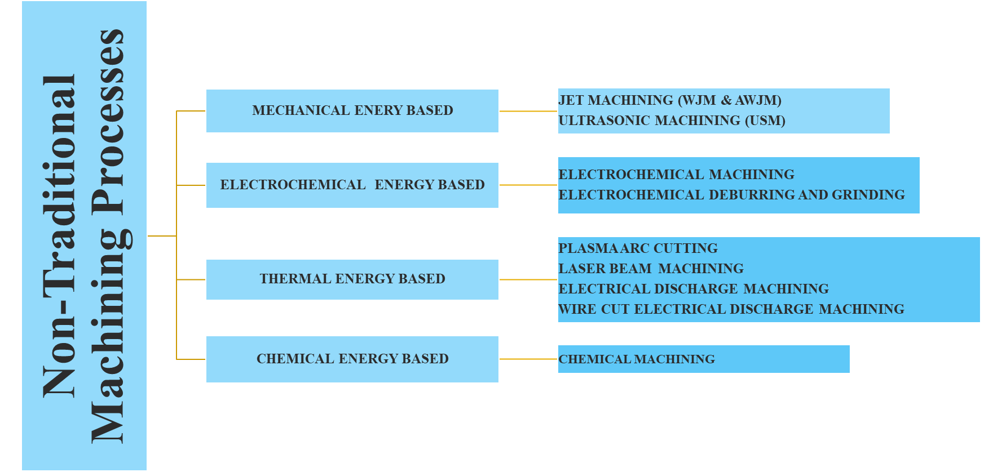
Figure 1.3 Non-traditional Machining Processes
1.2 ELECTRICAL DISCHARGE MACHINING (EDM)
The Electrical Discharge Machining (EDM) process removes material from the work material that conducts electricity through concentrated heating, melting, and vaporization. This process produces A spark in the gap between the metal and the electrode. This high-intensity spark dissipated higher thermal energy in the form of heat. The material immersed in dielectric fluid tends to melt due to intensive and concentrated heating upon heat dissipation. The dielectric fluid removes the molten metal through flushing operation. Material removal is achieved in three phases (Marshi et al., 2016). In the first phase, the dielectric fluid particles entrapped between the electrode and the material to be machined are polarized through the electric field set by applying the potential difference. Upon polarisation, the resistance of the dielectric fluid to conduct electricity reduces, enabling the current to build and come into contact with the workpiece in the form of a spark. In the presiding phase, the flow of current increases, resulting in plasma formation. The dielectric fluid vaporizes due to the increased intensity of heat and pressure, wherein material removal occurs. At the final stage, the materials in the molten state tend to solidify, and the resistivity of dielectric fluid toward the electricity increases. The mass of material removed by heat application can be controlled by exercising proper control over the variable operating parameters (Khan & Sudhakar Rao 2019). Generally, the EDM process is used to process metals used for making dies, tools, nozzles in gas turbines, blades of turbines, automotive parts, biomedical applications (implants), valves for hydraulic applications, making holes up to micro-level, etc. (Ayanesh & Anand 2019). In this type of machining, the tool material is not mandatory to have superior hardness compared to the material to be shaped as the material is removed through erosion. The significant positive aspects of EDM processes are listed below.
- It can remove unwanted stock irrespective of the material's mechanical properties that must be machined.
- The process leaves no sign of residual stress, as cutting force is not involved in conventional machining.
- The material can be shaped to any profile unless the tool can be shaped as required.
- Materials with thin cross-sections can be machined with higher dimensional accuracy.
- It removes stock at a higher rate than other NTMPs that remove material through abrasive action.
Despite the above-mentioned positive aspects, it adds some limitations to it. They are as follows.

CHAPTER 2
LITERATURE SURVEY
Many research works have been conducted on various materials, from low-performance steels to advanced composites, using a machining process. PMEDM is one method used for surface modification and material removal on conductive materials. The process is used to process materials used in applications such as biomedical (implants), dies, molds, critical components for aerospace applications, tools, and so on. So, literature studies were conducted on machining the materials for the above-said applications using PMEDM. The possibilities of improvement in the process through parameter setting are studied through a literature survey. A survey was conducted on the optimization techniques used for optimal parameter setting. Overall, the chapter focuses on the previous works performed over the past decade, and a summary of the literature is presented. Finally, the research gaps identified through intensive literature studies are challenges and opportunities for the audience to contribute to the advancement of PMEDM.
  - EFFECT OF POWDER TYPE, SIZE, AND CONCENTRATION
Haque et al. (2019) concentrated on effectively machining D3 steel with two different electrodes and aluminium particles suspended to varying concentrations in the dielectric fluid to improve the final product's surface finish. The brass electrode outperformed the copper electrode in producing the final product with a better surface finish. The average SR for the D3 steel machined with brass was much lower than the SR when machined using the copper electrode. It was exposed that the minimum SR was recorded for a powder concentration of 1 g/lit. Fadhil & Aghdea 2020 explored the impact of Graphite- Silicon Carbide (Gr-SiC) powders mixed with the transformer oil at varying proportions for machining High Speed Steel (HSS). The study revealed that a maximum powder concentration of 10 g/lit produced better results than conventional EDM, considering all the performance measures (MRR, SR, and TWR). The MRR, SR, and TWR were found at the maximum powder concentration of 0.492 g/min, 0.00126 g/min, and 3.51 µm, respectively. It was affirmed that the powder concentration (P_{CON}) had significantly improved the MRR and SR following current (I_{C}). Le 2021 investigated the efficacy of Tungsten carbide-suspended EDM oil (Fluid 2) for machining SKDF 61 plates. Upon investigation, P_{CON} showed a significant improvement in Microhardness, SR, and surface Morphology. The SR recorded a value that was 57.984 % lower than the SR obtained with plain dielectric fluid at 40 g/lit of P_{CON.} Also, the Surface Morphology and the microhardness showed improvement at 60 g/lit of P_{CON.} All the measures concerned for investigation showed improvement at the least I_{C} = 1A.
Sundriyal et al. (2021) evaluated the effect of three different powders mixed with two dielectric fluids, oxygen and argon, for shaping EN 31 alloy steel. The studies revealed that the graphite powders suspended in oxygen gas outperformed other combinations when considering MRR. The lowest SR (1.1 µm) of the machined EN 31 specimens proved that the combination of graphite powder and argon gas improved the surface finish. The zinc powder and argon gas mixture proved vital in reducing the residual stress under tensile load to the lowest of 229 Mpa and raising the microhardness to 820.3 VHN. The gas-assisted PMEDM generally produced better surface modification on EN31 alloy steel. Rouniyar & Shandilya 2020 improvised the PMEDM process with the assistance of magnets to hold the AA6061 to study the MRR and TWR while machining with EDM oil mixed with aluminium powders. They improved the MER and reduced the TWR by a small margin compared to the typical EDM process. The addition of aluminium powders had a mild impact on improving MRR and reducing the TWR. D3 steel was machined with varying concentrations of nano Silicon Carbide (SiC) powder suspended in dielectric fluid. The Mean Material Extraction Rate (MER) was increased when the concentration of SiC was raised to 2.812 mm³/min, 24.7 % higher than the MER obtained with a typical EDM process. Also, 0.6 g/l of P_{CON} was the most effective in improving the MER (Korada et al.2019). In an investigation featuring OHNS, H13, and D2 steel, Tungsten Carbide (WC) powders were mixed with the dielectric fluid at a fixed concentration of 15 g/lit. Incorporating WC into the dielectric fluid for machining the above steels has raised more than 100 % microhardness for all three materials. However, WC was most effective in increasing the microhardness of H13 steel compared to OHNS (which posted the minimum hardness of the three materials), with an approximate difference of 3.5 % (Kumar & Uma 2012).
Kolli & Kumar 2014 explored the effect of Boron Carbide (B₄C) powders with an approximate size of 20 – 30 µm on the performance measures at varying powder concentrations. The addition of B₄C has comparatively increased the MRR and surface finish at a powder concentration of 15 g/lit for machining Ti-6Al-4V titanium alloy. At 1 g/lit of B₄C concentration, the TWR was minimal and formed a Recast Layer. The machined surface had Microcracks, Voids, and craters of different sizes. Bikramjit et al. (2015) succeeded in machine H13 tool steel by using three different-sized Chromium powders mixed with the dielectric fluids. The chromium powder of 15 microns size assisted in achieving maximum MRR than 5 and 10 micron-sized powders. However, in the case of TWR reduction, 10 micron-sized powders were more effective than 5 and 10 micron-sized powders. Additionally, the 15-micron-sized powders effectively achieved optimal MRR and TWR.
Ramesh & Jenarthanan (2021) assessed the impact of three different powders, graphite, manganese, and silicon, at three different concentrations on machining Nimonic alloy 75. The study exposed that powder concentration had a greater effect on the variation in SR and TWR when mixing silicon powder with the dielectric fluid. At the same time, graphite powder was more effective in increasing the MRR than the other two powders. Manganese powder mixed with dielectric fluid at 3 g/lit produced enhanced performance measures. When the aluminium powder was mixed with kerosene dielectric fluid at a rate of 2.5 g/lit to machine Ti-6Al-4V alloy, increasing the current undoubtedly improved the MRR. Stable plasma was stable, TWR had improved by 82 %, and the SR increased with an increase in current. Also, the surface integrity improved with smaller cracks and heat-affected zones. Reduced cracks indicate improved metallurgical properties, confirming aluminium powder's significance (Ilani & Khoshnevisan 2021). Similarly, in another work on RENE 80 alloy, the RCL formation was analyzed for various powder concentrations. Gr and Al were used in the analysis, and it revealed that the presence of higher levels of carbon and oxygen shows that the dielectric fluid has decomposed (Sugunakar et al. 2017).
The performance measures have significantly improved when machining Rene 41 steel using a mixture of three different powders. When added at a higher concentration (60g/lit), the composite powders have yielded higher MRR and lower SR. Nevertheless, the TWR was lower only when the powder concentration was lower (20 g/lit). Powder Concentration has significantly reduced the SR with a maximum influence of 57.41 %. In the case of the other two performance measures, the current has been the contributing parameter with 85 % and 84 %, respectively (Sabareesan & Vasudevan 2021). Uniform machining was possible with the Al₂O₃ mixed kerosene (5g/lit) while removing material from Ti-6Al-4V alloy using the PMEDM process. The machined surface showed a small crack density and tiny cavities. The machining time has been reduced to a significant level in the presence of Al₂O₃ particles when compared to the typical EDM processes, leading to effective cost and time management. Contamination of kerosene during machining has resulted in the formation of Carbide and oxides on the machined surface. Also, oxygen and carbon particles on the surface were identified after machining (Taherkhani et al.2021). Surfaces machined with PMEDM (4 g/L aluminum powder) exhibited reduced cracks, smaller craters, and enhanced smoothness compared to conventional EDM surfaces. Debris accumulation was minimized, improving the surface integrity of machined parts (Dinesh et al. 2021, Sergiy Plankovskyy et al. 2021). An improvement of TWR by 92.8 % was evidenced when Inconel 718 was machined with Gr powder suspended EDM process at 20 amp of current (Sahu & Datta 2019).
Xu et al. (2021), have machined titanium alloy with three different powders (Chromium oxide (Cr₂O₃), Al₂O₃, and B4C) at a fixed concentration of 6 g/lit. They introduced a new methodology called sloshing to effectively remove the spark gap debris. When combining PMEDM and sloshing, the MRR and TWR enhanced with B₄C particle inclusion compared to the other two powders. The RCL thickness reduced drastically upon the inclusion of the sloshing technique compared to the typical PEDM process. The RCL thickness has declined to an invisible level (below 4.1 µm), and the SR of that machined surface was 0.205 µm. Zhang et al.2021, improvised the typical PMEDM with Ultrasonic assistance for machining 7Cr13Mo steel using TiC particles at a fixed concentration of 10 g/lit. Compared to the Typical EDM process, reducing cracks and crater size with smaller SR was possible using the ultrasonic-assisted PMEDM process. Also, the MRR and Microhardness improved through this improvisation by up to 57 % and 78 %, respectively. The improvement observed in Microhardness and MRR was achievable at maximum Peak current and pulse duration. In the case of SR, lower peak current and lower pulse duration produced lower SR.

CHAPTER 3
INVESTIGATIONAL ARRANGEMENT
This chapter describes the setup, process variables chosen for investigation, and experimental analysis strategy. Also, the materials under investigation and the tools used are addressed here. Figure 3.1 depicts the experimental setup used for the investigation. The experimental setup includes an EDM 10600 machine with a table size of 990 mm x 560 mm. The maximum limiting parameters of the machine were 99 µs, 9 µs, and 51 amps of Pulse ON time, Pulse OFF duration, and Current, respectively. A machining tank made of galvanized iron is placed over the work table of the EDM machine for testing purposes. The recirculating pump and the provision for holding the workpiece are housed in the Machining tank. By focusing the delivery tube in the spark gap, the recirculating pump allows flushing (the gap between the tool and the workpiece).
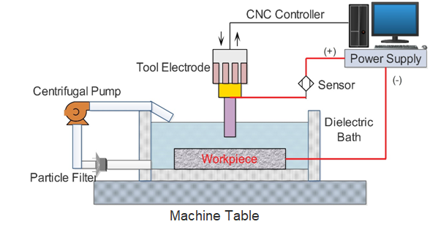
Figure 3.1 Experimental Arrangement
A stirrer is added to the arrangement to prevent the settling of debris and powders suspended in the EDM oil. Throughout the experiment, the stirrer rotates at a constant speed. A filtering system is also included to remove debris formed during experimentation in the spark gap. To avoid debris being recirculated through the pump, the debris is flushed through this filtering setup. The filter employed in the setup includes three layers of differing mesh sizes due to the size of the powders suspended in the dielectric fluid (90,75 and 45 microns).
3.1 MATERIALS OF INVESTIGATION
Two materials, namely, Nimonic Alloy 90 and OHNS, are chosen for investigation in this work. The main constituents of the Nimonic alloy 90 are nickel, chromium, and cobalt. The addition of aluminium and titanium strengthens these types of materials and has excellent temperature resistance. This creep-resistant material is used in a wide range of applications, such as the manufacturing of nozzles, turbine blades, etc., The properties of the Nimonic Alloy 90 are shown in Tables 3.1 and 3.2. Figures 3.1 and 3.2 show the material's surface as received and the EDX results.
Table 3.1 Composition of Nimonic Alloy 90 in percentage
Elements | % Weight of Elements
C | 0.079
Si | 0.185
Mn | 0.24
Ti | 2.7
Cr | 18.004
Cu | 0.029
Co | 15.248

Table 3.1(Continued)
Mg | 0.002
Mo | 0.164
W | 0.174
B | 0.001
Zr | 0.019
Pb | 0.002
Ta | 0.047
S | 0.005
Al | 1.246
Nb | <0.001
Sn | 0.007
Hf | 0.03
P | 0.006
V | <0.001
Fe | 0.745
Ni | Remaining

Table 3.2 Physical Properties of Nimonic Alloy 90
Material | Density (Kg/cm³) | Melting Point (⁰C) | Hardness (HV) | Tensile Strength (MPA)
Nimonic Alloy 90 | 8.18 x 10⁻⁶ | 1310 | 243 | 850

CHAPTER 6
CONCLUSION
This chapter describes the conclusions from the experimentation in sections pointing to individual materials, setup, process variables chosen for investigation, and analysis strategy.
- Machining OHNS using TiC (40 microns) mixed with dielectric fluid at 75 µs T_{ON}, 2 µs T_{OFF}, 20-amp I_{C}, & 6 g/lit P_{CON} results in a higher MRR.
- The parameter contribution order is I_{C} > P_{CON} > T_{ON} > T_{OFF}.
- T_{OFF} provides the least contribution to increasing MRR. I_{C} has the highest percentage contribution of 50.77%, followed by P_{CON} with 24.67%. T_{ON} by 21.81%, and T_{OFF} by 1.84%. The R-Sq = 99.09% & R-Sq (adj) = 95.46%.
- Machining OHNS using TiC (40 micron) mixed dielectric fluid at 30 µs T_{ON}, 6 µs T_{OFF}, 5 amp I_{C}, & 2 g/lit P_{CON} results in a lower TWR. The part played by each parameter was T_{ON} > I_{C} > T_{OFF} > P_{CON}.
- The percentage of the contribution of each input is T_{ON} by 33.1% and I_{C} by 24.7 %. T_{OFF} is 20.7 %, while P_{CON} is 19.9 %, with R-Sq = 98.48% & R-Sq (adj) = 92.38%.

REFERENCES

- Aabid Tawfiq, Maan & Azzam Sabah Hameed 2015, ‘Effect of Powder Concentration in PMEDM on Machining Performance for Different Die Steel Types’, Engineering and Technology Journal, vol. 33, no. (9A), pp. 2174–86.
- Amorim, Fred L., Vitor A. Dalcin, Paulo Soares & Luciano A Mendes 2017, ‘Surface Modification of Tool Steel by Electrical Discharge Machining with Molybdenum Powder Mixed in Dielectric Fluid’, International Journal of Advanced Manufacturing Technology, vol. 91, no. 1–4, pp. 341–50.
- Boopathi, R, Sundaram, S, Senthilkumar, C & Prabhu, M 2018, ‘Investigation on Electrode Vibration Behavior of Machining Characteristics in Nano-TiC Mixed an EDM Machining Performance’, Journal of Balkan Tribological Association,
vol. 24, no. 3, pp. 363–80.
- Boopathi, Rajendran, Sengottuvelu Sundaram, Chinnamuthu Senthilkumar & Muthusamy Prabu 2017, ‘Effect of Machining Characteristics of Nano-TiC Mixed Dielectric Fluids on Inconel 718 in the EDM Process’, Materialpruefung/Materials Testing, vol. 59, no. 4, pp. 402–8.
- Chow, Han Ming, Lieh Dai Yang, Ching Tien Lin & Yuan Feng Chen 2008, ‘The Use of SiC Powder in Water as Dielectric for Micro-Slit EDM Machining’, Journal of Materials Processing Technology, vol. 195, no. 1–3, pp. 160–170.
- Dewangan, S & Biswas, C 2013, ‘Optimisation of Machining Parameters Using Grey Relation Analysis for EDM with Impulse Flushing Shailesh Dewangan and Chandan Kumar Biswas *’, Int. J. Mechatronics and Manufacturing Systems, vol. 6, no. 2,
pp. 144–58.
- Dhas, D, Ebenezer Jacob, S & Velmurugan, C & Leo Dev Wins, K 2018, ‘Investigations on the Effect of Tungsten Carbide and Graphite Reinforcements during Spark Erosion Machining of Aluminium Alloy (AA 5052) Hybrid Composite’, Silicon, pp. 1–13. https://doi.org/10.1007/s12633-018-9817-0.
- Fadhil, Safa & Shukry Aghdeab. 2020, ‘Effect of Powder-Mixed Dielectric on EDM Process Performance’, Engineering and Technology Journal, vol. 38, no. 8, pp. 1226–35.
- Gavali, Pankaj B, Chandan A. Waghmare & Kalashetty, SS 2016, ‘Experimental Investigation of Changing Polarity in Powder Mixed Electric Discharge Machining (PM-EDM)’, International Journal of Engineering and Technology, vol. 8, no. 5, pp. 2049–58.
- Groover & Mikell, P 2013. Fundamentals of Modern Manufacturing Material, Processes & Systems. Thomson Digital and Pronted, Quad Graphics, Wiley, United States. (Sample Book citation)
- Huda, Zainul 2019, ‘Nontraditional Machining Processes’, Manufacturing, pp. 271–89. (Sample Book citation)
- Marashi, Houriyeh, Davoud M. Jafarlou, Ahmed AD Sarhan & Mohd Hamdi 2016, ‘State of the Art in Powder Mixed Dielectric for EDM Applications’, Precision Engineering, vol. 46, pp.11–33.

